**Week 5 assignment: Cloud and API deployment**

**Name:** Roger Burek-Bors

**Batch code:** LICAN01

**Submission date:** March 28, 2021

**Submitted to:** Data Glacier

1. Introduction (common with assignment for week 4)

I am fan of cars therefore I decided to use for this week assignment “FuelConsumptionCo2.csv” which is a 1000-point data set about modern cars. This data set contains such features like:

* model of car,
* year of introduction,
* engine size,
* cylinder,
* fuel consumption,
* CO2 emissions.

My aim was to create a prediction model that would help to determine CO2 emissions when it comes to engine size.

1. Building the model (common with assignment for week 4)

<https://github.com/rodbergerrone/VC/blob/rbb/Model_deploy/FuelConsumptionCo2_Regr.ipynb>

1. I used Jupyter Notebook for “FuelConsumptionCo2.csv” analysis. I determined 4 most promising features for CO2 emissions predictions:

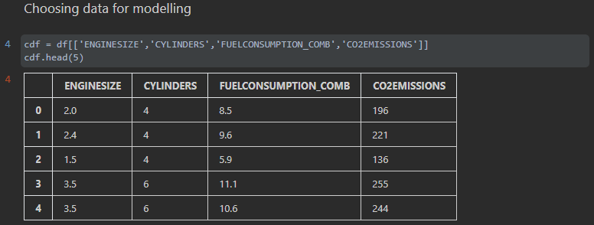

1. Analysis led to conclusions that features like engine size, cylinders and fuel consumption have almost linear correlation with CO2 emissions feature therefore a linear regression model could be built. To keep this assignment simple I decided that model will be predicting CO2 emission based on only one feature – engine size.

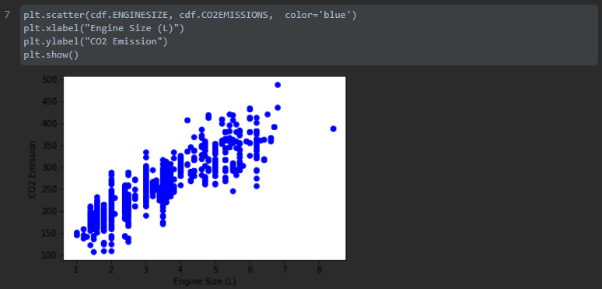

1. Building the model was achieved as on following pictures with help of Scikit-learn library:

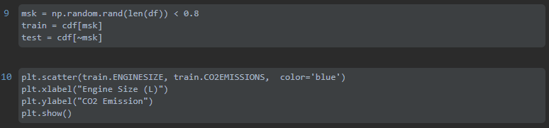

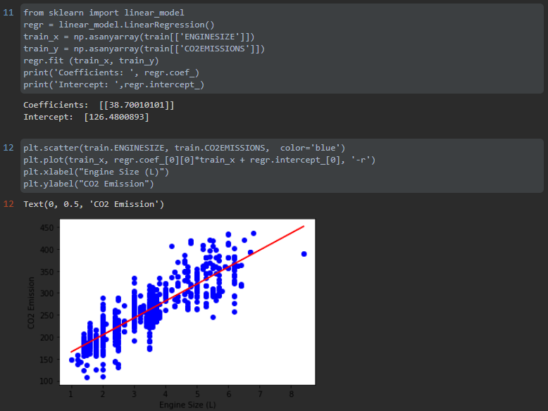

1. I performed model evaluation to see how prediction behave in correlation to data in “FuelConsumptionCo2.csv” and on leaflets of car dealerships. It worked really fine. I also checked metrics available in Scikit-learn library:

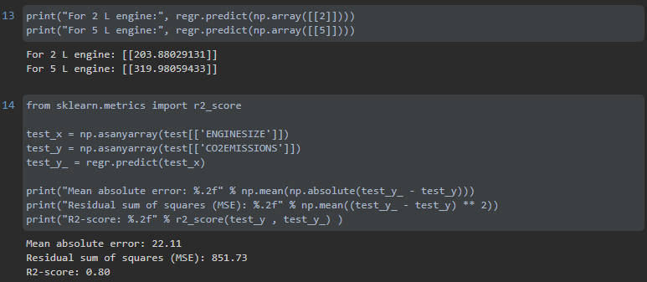

Coefficient of determination is 0.8 which in my opinion is quite good.

1. Then I serialized the model with Pickle library as “pickle_model.pkt”:



1. Building Flask backend (common with assignment for week 4)

<https://github.com/rodbergerrone/VC/blob/rbb/Model_deploy/deploy_flask.py>

I used Pycharm to develop Python code for backend:

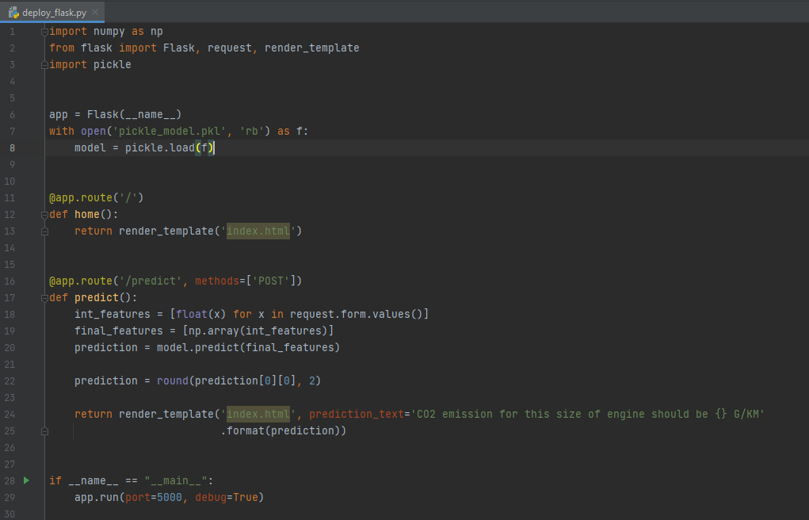

1. Building Flask frontend (common with assignment for week 4)

<https://github.com/rodbergerrone/VC/blob/rbb/Model_deploy/templates/index.html>

I used Pycharm to develop Python code for frontend:

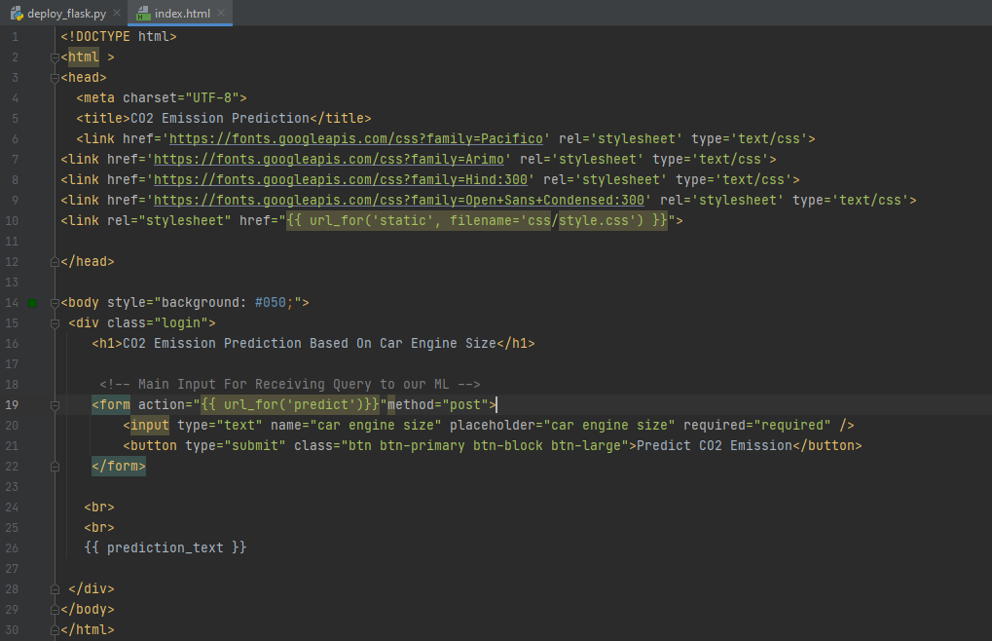

1. Performing predictions on local network with Flask (common with assignment for week 4)

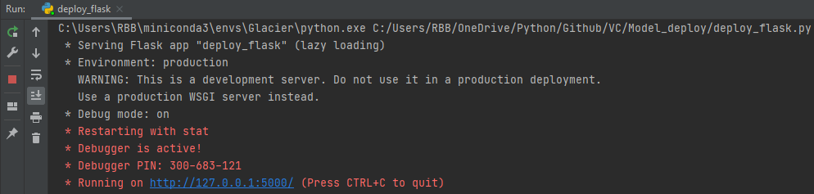

Comparing model predictions with automotive specifications:

1. frontend of my predictor – the result: 188.4 G/KM is for 1.6 L engine
2. specification of Toyota Yaris GR – the result: 186 G/KM is for 1.6 L engine
3. Deployment on Cloud with Heroku after creating account on [www.heroku.com](http://www.heroku.com)
4. creating Procfile which will guide Heroku on how the application should run:



1. creating requirements.txt which will guide Heroku about installation of necessary libraries:

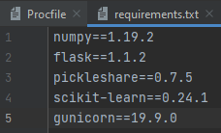

1. linking Github repository with Heroku account and setting deployment method:

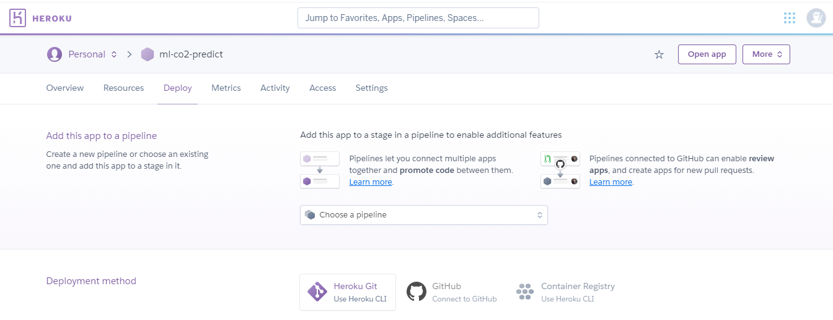

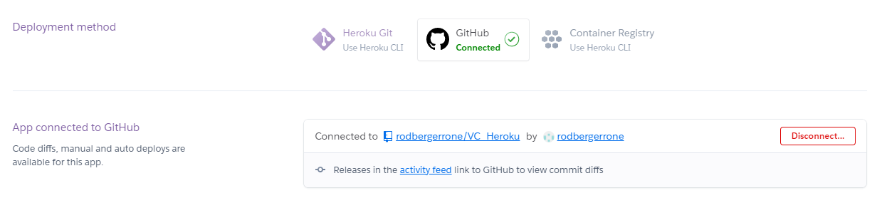

My model was successfully deployed to Heroku and can be accessed at:

<https://ml-co2-predict.herokuapp.com/>

1. API feature was implemented as the separate method in flask app (see code below). To access API please go to <https://ml-co2-predict.herokuapp.com/api/> and after slash provide size of engine.

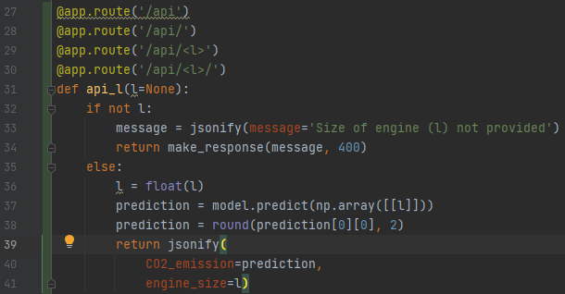

**Web based implementation:**

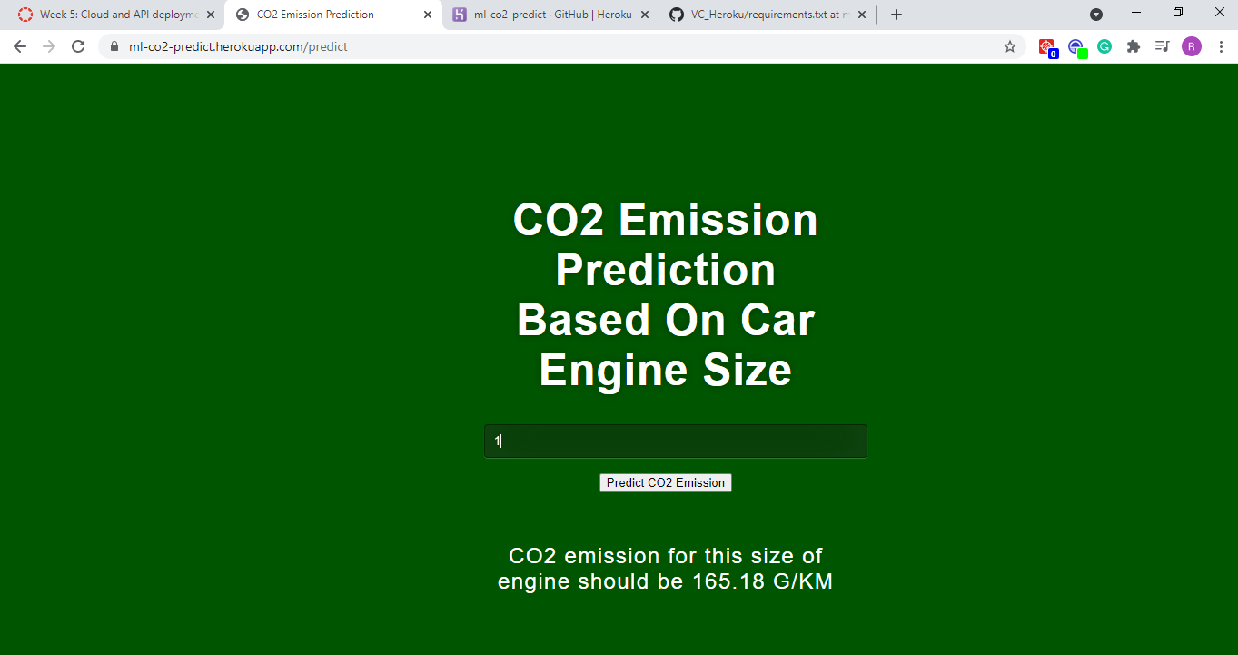

**API based implementation:**

